Dessa Shapiro

3/15/20

Period 1

**Hominid Evolution summary**

**Intro:** I got to choose 5 hominids to research on and I learned a lot about how these different species evolved from a common ancestor and how different species changes and I got to learn about our history and think about how much we changed. This also allowed me to look at the concept of evolution differently and start to realize how new we are on this earth and also how much we've changed about the world and our structure in such a short amount of time.

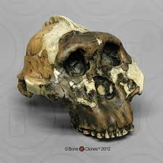

**Paranthropus / Australopithecus boisei**: The Australopithecus boisei lived from about 2.3 to 1.4 million years ago and were one of the only hominids that were herbivores. They lived in eastern Africa and their diet mostly contained nuts, seeds, and hard fruit because of their powerful and big jaws. Their lives would mostly consist of roaming eastern Africa gathering food and looking for water. They evolved mainly from the Australopithecus afarensis and are more closely related to Paranthropus Robustus and Australopithecus africanus. Unlike many homo species, this branch evolved with different features such as bigger jaws and a more round jaw and face shape. Scientists are not positive of why the Australopithecus boisei went extinct but the most plausible possibility would be that due to their bigger teeth and strang jaws meant for chewing vegetation. When the climate changed they could not adapt to the new food or not get enough energy and eventually went extinct.

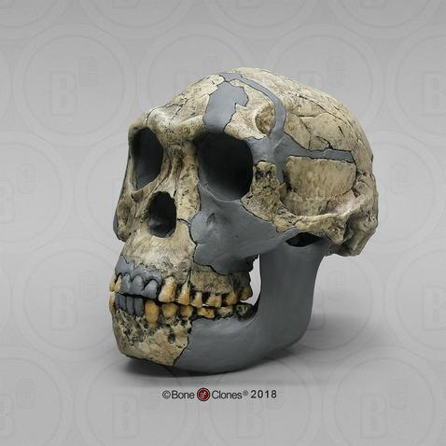

**Homo Habilis**: The Homo Habilis lived from 2.3 to 1.4 million years ago and was one of the earliest homo species. They were found to live in separate parts of sub-Saharan Africa, they were omnivores and their diet consisted of meat from leftover animal carcasses and some fruits and vegetables. They lived as scavengers searching for food, also roaming Africa living in groups. The Homo Habilis also evolved from the Australopithecus afarensis but unlike the Paranthropus Bias, the homo Habilis evolved into omnivores with smaller facial features and teeth that made it more suitable for eating meat. They also evolved with a bigger brain capacity with around 612cc and were the first hominids to start using stone tools. But the Homo Habilis still have many ape-like qualities. The Homo Habilis species are thought to have gone extinct because they did not continue to develop and change with the environment. They also did not improve their technology or increase their cc. Therefore, when the climate changed and new, more advanced species appeared they could not keep up with the competition and died out.

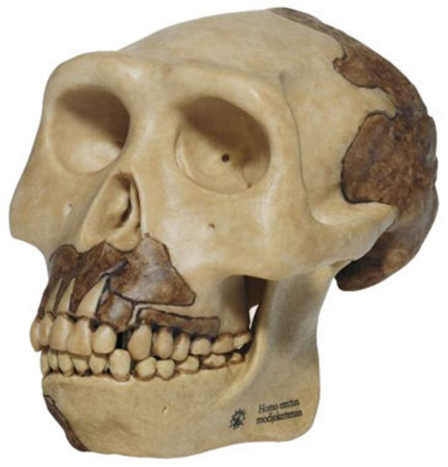

**Homo erectus**: The Homo Erectus species lived from 2 million to 100,000 years ago and was one of the first hominids to leave Africa. They lived in numerous locales across the globe, including South Africa, Kenya, Spain, China, and Java (Indonesia). Homo erectus evolved to be more advanced than Homo Habilis with a cc of 900. With a bigger brain size, they were able to make more advanced tools such as knives, hammers, and cleavers. They were also the first to use fire which allowed them to get more nutrition out of their food. They were omnivores and evolved having smaller teeth and a broader diet than hominids before them, containing tough meat and harder vegetables. Much like other species, the Hhomo Erectus were thought to have died out due to the inability to adapt as the climate changed. There are also examples that they were “lazy” and didn’t try to move into a different area with a safer environment, so they eventually died out.

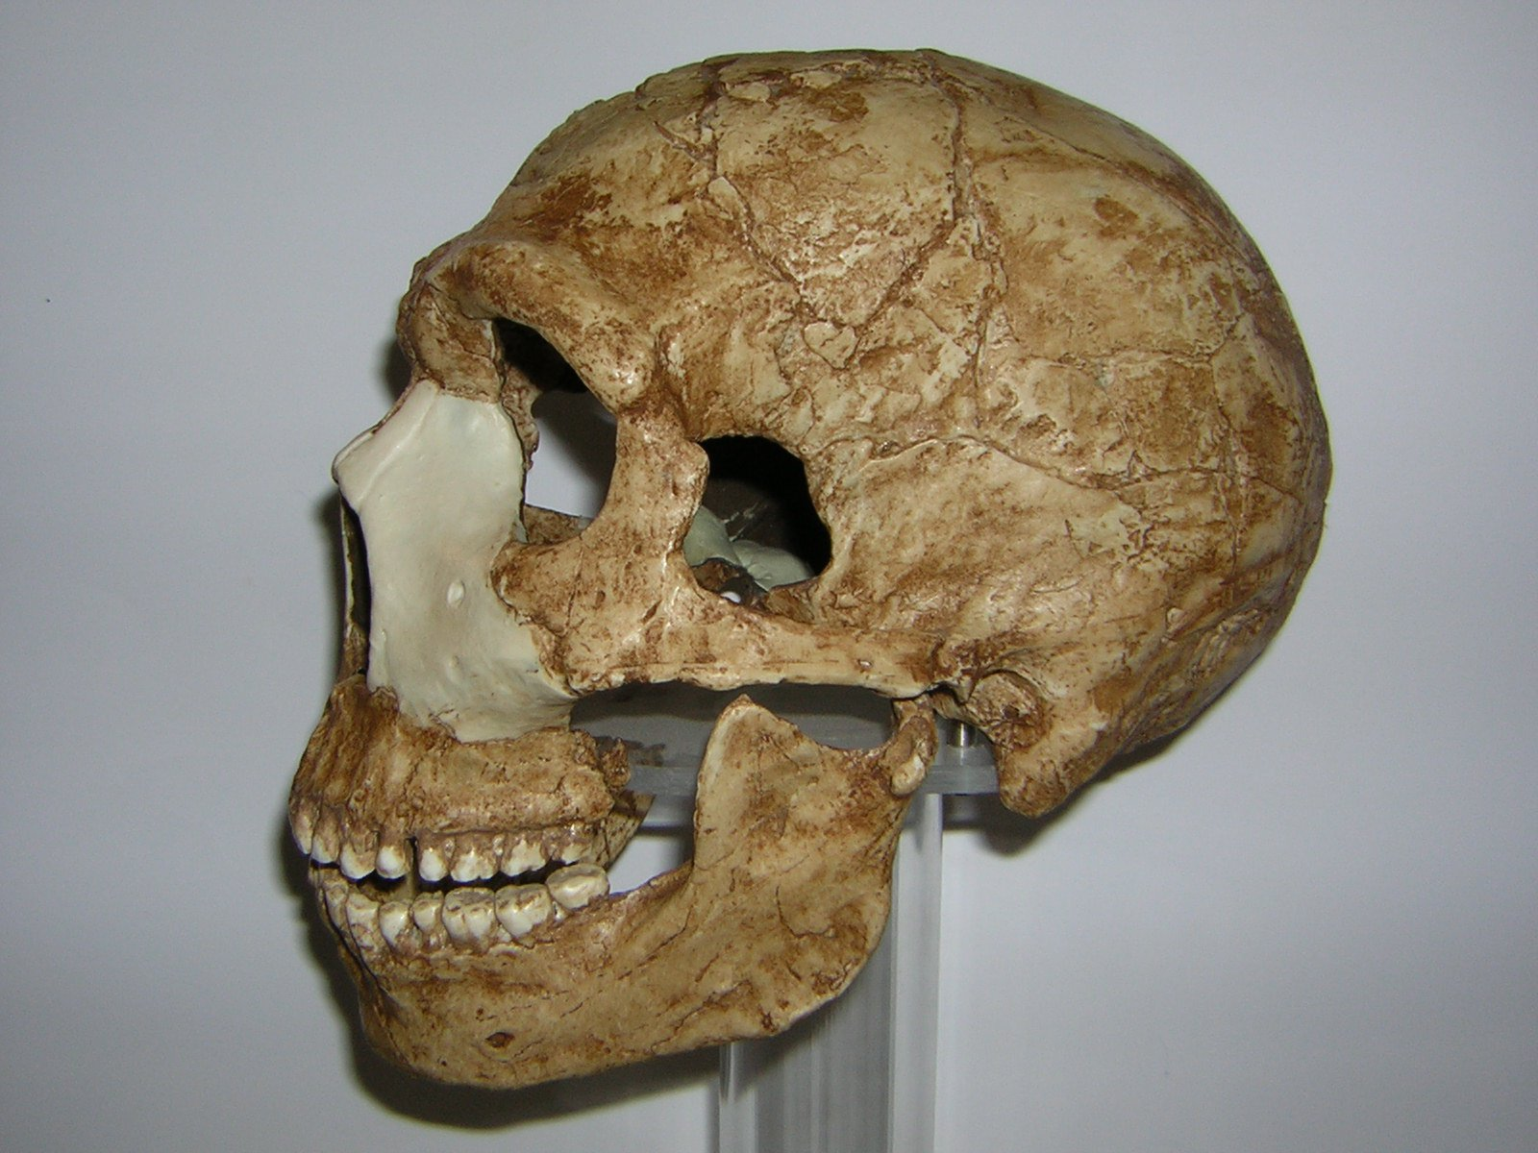

**Homo Neanderthalensis:** The Homo Neanderthalensis species lived from 130,000 to 40,000 years ago. The Homo Neanderthalensis is one of the most advanced hominids that lived, said to be as or even more advanced than homo sapiens. Homo Neanderthalensis was also omnivores and they originated in Africa but migrated to Eurasia long before other humans did. They eventually lived across Eurasia, as far north and west as Britain, through part of the Middle East, to Uzbekistan. Their lives were more sophisticated and there is evidence of advanced tools and even of religious ceremonies such as barring the dead and taking care of their young. The Homo Neanderthalensis evolved much like homo sapiens, they had a cc of 1500 which is bigger than homo sapiens. They also had a thicker brow then homo sapiens and are more robustly built. The most probable way that homo Neanderthalensis went extinct that scientists came up with was that they could not adapt their hunting methods. And with the competition for resources they had with homo sapiens, they could not get enough food. And what made the situation worse was the lack of animals because there has been an ice age before that.

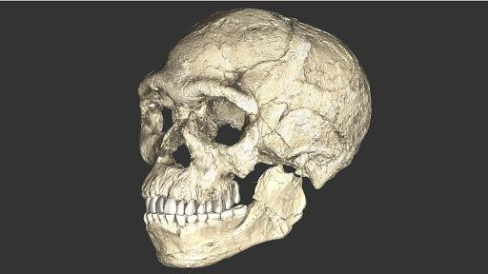

**Homo Sapiens:** Homo Sapiens have been around since 200,000 years ago till today and are the only hominids still alive. They originated from Africa like all other hominids but over time has moved to live everywhere on the globe. They are omnivores but have also found new ways to cook food and allow more nutrients. They lived more complex lives, with a very big brain and better functioning hands they were able to create tools and technology that has brought them to the top of the food chain. Homo Sapiens are very similar to Homo Neanderthals in the way they evolved. The main differences would be that homo sapiens have a slightly smaller face and a more vertical face. Homo sapiens lived in the same period as Homo Neanderthals which are proven to be as, or even more intelligent than us, so that raises the question, Why did they go extinct and not us? Some scientists say that homo sapiens had a much bigger population than the Homo Neanderthals, so when the climate changed and resources decreased they had a greater advantage and survived.

**Conclusion:** Overall all of these species have had a big impact on how we look and function today. All of these species share a common ancestor so seeing how all these species grew, lives then died opens a window into our past. We also have to keep in mind that none of these species have left for good because they're in our DNA. There is a lot of overlap of species and it’s likely that they crossbreed and spread their genes down to us. So it’s important to learn about our distant ancestors and contemplate evolution and the past.